***Advertisements from News API and Open source***

1.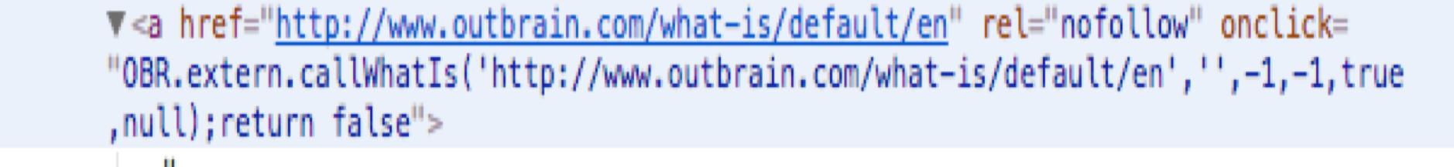

2.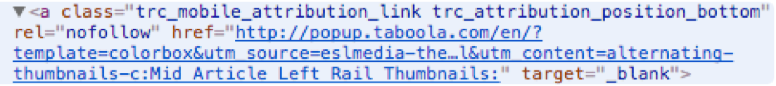

3.

4.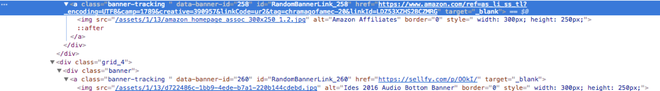

|  |  |
| --- | --- |
| **News Sources** | **Ads** |
| Abc | None |
| Guardian | Google |
| CNN | Outbrain, Google |
| MoneyCNN | Outbrain, Google |
| Independent | Taboola, Google |
| Reuters | Revontent, Google |
| Time | Outbrain, ideal media, dianomi, Google |
| Fortune | Outbrain, dianomi, GobankingRates, Google |
| BBC | Outbrain, Google |

|  |  |  |
| --- | --- | --- |
| **News Sources** | **Type** | **Ads** |
| <http://100percentfedup.com/> | Bias | Google, Outbrain |
| <https://4threvolutionarywar.wordpress.com/> | Bais | Google |
| <http://addictinginfo.com/> | Clickbait | Google, Adblade |
| <http://amusmentic.com/> | Clickbait | Google, Content.ad |
| <http://www.activistpost.com/> | Conspiracy | Google, Revcontent |
| <http://bullionbullscanada.com/> | Conspiracy | Google |
| <http://24wpn.com/> | Fake | Google, Content.ad |
| <http://abcnews.com.co/> | Fake | <http://sockitforward.com/donate/> |
| <https://www.amren.com> | Hate | Taboola, (See number 2) |
| <http://www.barenakedislam.com/> | Hate | FeedNetwork, Revcontent, Content.ad, |
| <https://americankabuki.blogspot.ie> | Junk | Google |
| <http://consciouslifenews.com/> | Junk | Google, Random ads |
| <http://www.dailyleak.org/> | Satire | Content.ad |
| <https://www.advocate.com/> | Political | Google, (See number3) |
| <https://www.chroniclesmagazine.org/> | Political | (Amazon, Sellfy) Under a div class see number 4 |
| <http://www.christianpost.com/> | Reliable | Google |
| <http://www.express.co.uk/> | Rumor | Google, Outbrain, plista |
| <https://awazetribune.com/> | Satire | Google, |
| <http://www.anonews.co/> | Unreliable | Google, |
|  |  |  |